HAIR LOSS QUESTIONNAIRE

Name: DOB:
Race: Height: Weight:

- When did you last have a normal head of hair?
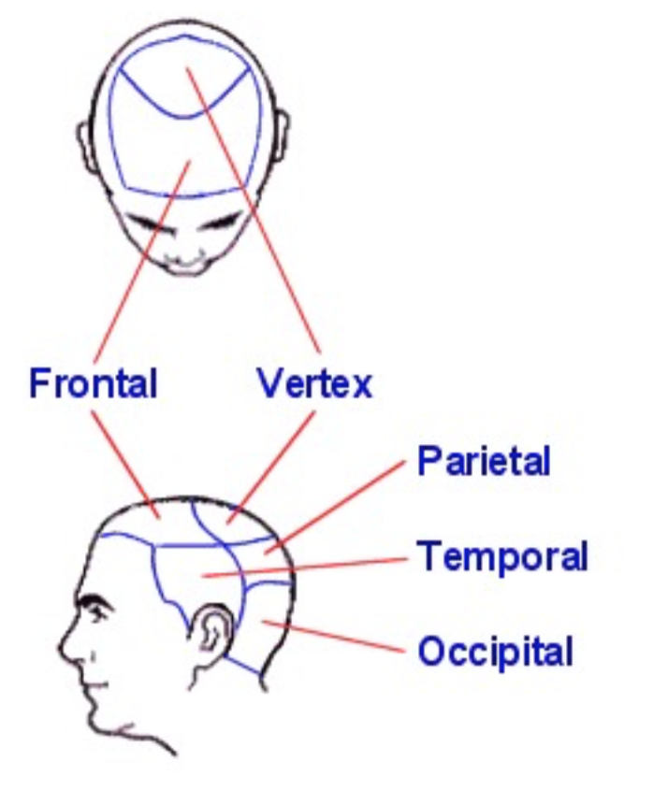
- Was onset of hair loss sudden or gradual?
- Is your hair coming out “by the roots” or is it breaking off?
(Please shade in areas of location of hair loss on the map to the right.)
- Is your hair thinning or is it shedding?
- How often do you wash your hair?
- What hair products do you use?
- Do you use hot rollers, ponytails, braids, twists, locks, extensions, or weaves? How long? How often?
If you have a weave, is it sewn in or glued?
- Do you use hot combs, press and curl, curling irons or otherwise apply direct heat to your hair?
- What type of hair chemicals do you use for your hair?
Hair dye? Name:
Relaxer? Name:
Is it a relaxer that contains lye? Do you have a permanent wave?
Name: How long? How often?
- Does your scalp itch? Little Moderate A lot (Circle)
- Do you get sores in your scalp? Yes No
- Do you have Seborrheic Dermatitis? Yes No Psoriasis? Yes No
- What medications are you allergic to?
- What medications do you take?
Do you use herbs or supplements? Yes No
Name:
- If you are on birth control pills, which one?
Have you recently started? When?
Or stopped your birth control pills? When?
- Are you on any other type of hormone treatment?
Which one? How long?
Or stopped? When?
- If applicable, are your menstrual periods regular? Normal flow?
If not, what is happening? How long?

- Have you gone through menopause? Age?
- Are you on any type of weight loss diet?
Are you on a low protein diet?
Are you a vegetarian (type)?
- Any hair loss in men in your family? Baldness?
Any hair loss in women in your family? How thin?
Any family history of thyroid disease, anemia, or lupus?
- What medical problems do you have?
- Do you have?
  - Severe headaches □ Yes □ No
  - Double vision □ Yes □ No
  - Excess facial hair □ Yes □ No
  - Excess body hair □ Yes □ No
  - Cystic Acne □ Yes □ No
  - Discharge from breast □ Yes □ No
  - Deepening of voice □ Yes □ No
  - Enlargement of clitoris □ Yes □ No
  - Polycystic ovary disease □ Yes □ No
- Have you had in the last 3-12 months?
  - High fever □ Yes □ No
  - Childbirth □ Yes □ No
  - Severe infection □ Yes □ No
  - Flare of chronic illness □ Yes □ No
  - Major surgery □ Yes □ No
  - Over or under active thyroid □ Yes □ No
  - Low protein diet □ Yes □ No
  - Low iron in blood □ Yes □ No
  - Severe psychological stress □ Yes □ No
  - Start or stop birth control pills □ Yes □ No
  - Start or stop hormone treatment □ Yes □ No
  - Start or stop beta blocker medication □ Yes □ No
- Do you see a rash in your scalp or on your face?
If yes, please describe.
- Treatments previously tried? (Rogaine, Vitamins, Shampoos, etc.)
__________________________________________________________________________________
___________________________________________________________________________

